Digital Transformation X Green Transformation Seminar
-Meet DX & GX solution for a Sustainable Future-
As global environmental awareness continues to rise, achieving net-zero carbon emissions has become a focus of attention for all industries. Meanwhile, digital transformation is also an important consideration.
Therefore, in recent years, companies have adopted carbon reduction measures to minimize their environmental impact, while at the same time leveraging digitalization to improve efficiency and optimize processes to achieve the goal of a sustainable future.
We invite 4 Taiwanese industry giants - TONGTAI, HIWIN, QUASER and YCM - to unveil the technological trends and show us the technologies and applications of digital transformation and green transformation.
Seminar： Digital Transformation X Green Transformation
Date：Tuesday, September 19, 2023
Time：14:00-15:30
Location： Hall 16 Stand G31, EMO HANNOVER
📢📢Register for a sustainable future：
https://reurl.cc/nLVNDD

More information:
"

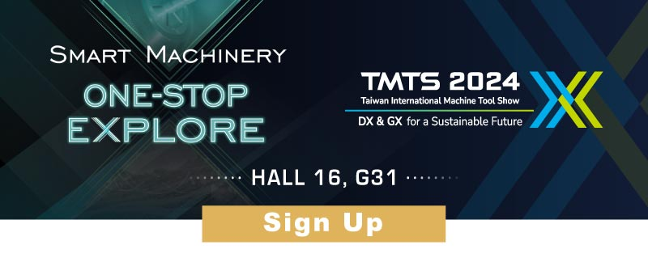

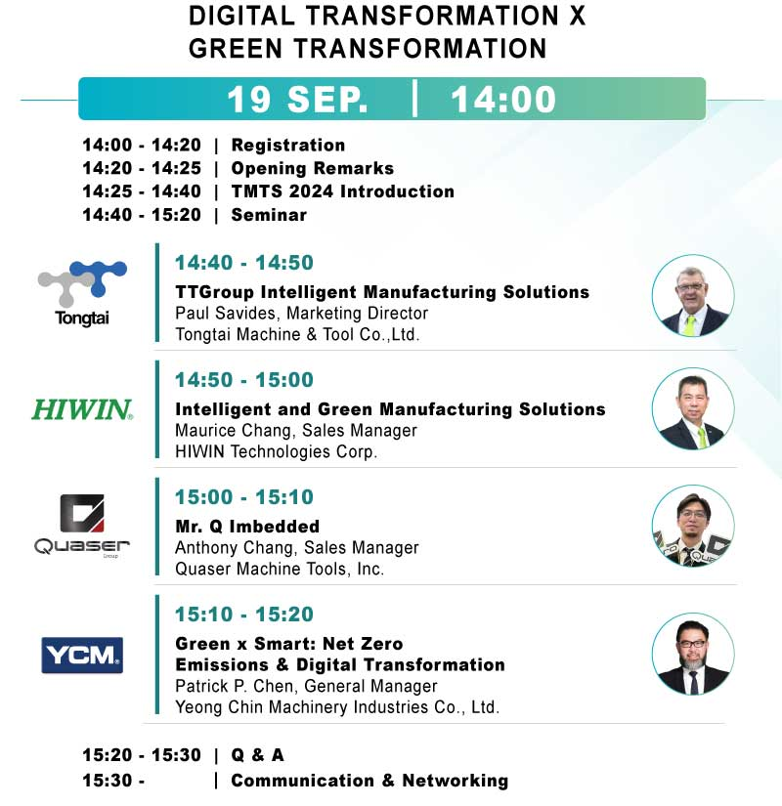

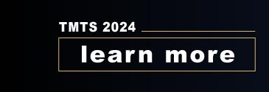 | 